**Batch: B-1 Roll No.: 16010122104**

**Experiment / assignment / tutorial No. 6**

|  |
| --- |
| **TITLE:**  Implementation of LRU Page Replacement Algorithm. |

**AIM:** The LRU algorithm replaces the least recently used that is the last accessed memory block from user. ______________________________________________________________________ **Expected OUTCOME of Experiment: (Mention CO/CO’s attained here)** ___________________________________________________________________

**Books/ Journals/ Websites referred:**

3. Carl Hamacher, Zvonko Vranesic and Safwat Zaky, “Computer Organization”,

Fifth Edition, TataMcGraw-Hill.

4. William Stallings, “Computer Organization and Architecture: Designing for

Performance”, Eighth Edition, Pearson. _____________________________________________________________________

**Pre Lab/ Prior Concepts:**

It follows a simple logic, while replacing it will replace that page which has least recently

used out of all.

a) A hit is said to be occurred when a memory location requested is already in the cache.

b) When cache is not full, the number of blocks is added.

c) When cache is full, the block is replaced which is recently used

**Algorithm:**

1. Start

2. Get input as memory block to be added to cache

3. Consider an element of the array

4. If cache is not full, add element to the cache array

5. If cache is full, check if element is already present

6. If it is hit is incremented

7. If not, element is added to cache removing least recently used element

8. Repeat step 3 to 7 for remaining elements

9. Display the cache at very instance of step 8

10. Print hit ratio

11. End

**Example:**

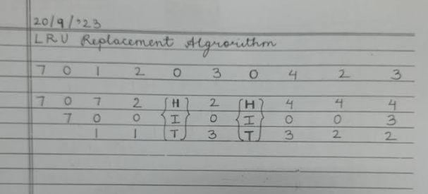

**Post Lab Descriptive Questions**

1. **Define hit rate and miss ratio?**

**Ans:**

Hit Rate: The hit rate, often referred to as the hit ratio, is a metric used to measure the effectiveness of a cache or memory system. It represents the percentage of memory accesses that are successfully retrieved from the cache without needing to access the slower main memory. Mathematically, it is calculated as the number of cache hits divided by the total number of memory accesses.

 Miss Ratio: The miss ratio, also known as the miss rate, is the complement of the hit rate. It represents the percentage of memory accesses that result in cache misses, where data must be fetched from the main memory because it is not present in the cache. Mathematically, it is calculated as 1 minus the hit rate.

    For example, if the hit rate is 90%, the miss ratio is 10% because 10% of memory accesses result in cache misses.

**2. What is the need for virtual memory?**

**Ans:**

Virtual memory is a memory management technique used by modern computer operating systems to provide several important benefits:

Increased Addressable Memory: Virtual memory allows programs to access more memory than physically available in the RAM. This is crucial for running large applications or handling multiple processes simultaneously.

Isolation: Virtual memory provides memory protection and isolation between processes. Each process has its own virtual address space, which prevents one process from accessing or modifying the memory of another process.

Simplifies Memory Management: Virtual memory simplifies memory management for both the operating system and application programs. Programs can allocate memory without worrying about the physical constraints of available RAM.

Efficient Use of Memory: Virtual memory enables efficient use of physical memory by swapping data between RAM and disk storage as needed. Frequently used data remains in RAM, while less frequently used data can be temporarily moved to disk, optimizing memory usage.

Security: Virtual memory can enhance security by isolating memory spaces. It helps prevent buffer overflow attacks and provides a layer of security by controlling memory access.

Multitasking: Virtual memory is essential for multitasking, allowing multiple programs to run simultaneously without conflicts over memory resources.

**Conclusion:** We learned the implementation of LRU Page Replacement algorithm.

**Date: 20/09/2023**